Women's Clothing: Trends and Analysis in the Fashion Industry
Technical Evaluation Report: CSV Upload Architecture, Dynamic Format Validation & Pre-Prediction EDA
Date: 04-11-2026 | Track: Dynamic CSV Upload, Validation Pipeline & Pre-Prediction EDA
1. Executive Summary
This technical report documents the design and deployment of the CSV upload and dynamic validation subsystem developed for the Women's Clothing project. To facilitate high-throughput external batch inference, a fault-tolerant ingestion pipeline was created that verifies delimiter formatting, detects encoding anomalies, dynamically resolves missing text and numerical metrics, and surfaces pre-prediction exploratory data analysis (EDA) charts before triggering batch transformer model evaluation.
2. Dynamic Schema Validation Rules
Table 1 outlines the complete schema specification enforced during CSV parsing. Text fields are verified for valid UTF-8 character encoding, while numerical attributes are validated against realistic retail boundaries.
Attribute | Type | Requirement | Validation Rule | Imputation Strategy
Review Text / Full_Review_Text | String (Text) | Mandatory | Length >= 1 token; UTF-8 string; alphanumeric check | Impute with empty string or flag for moderation
Rating | Integer (Numeric) | Optional (Recommended) | Integer in range [1, 5]; non-null | Coerce to numeric, impute with corpus median (4.0)
Age | Integer (Numeric) | Optional | Integer in range [18, 100] | Coerce to numeric, impute with cohort median (41.0)
Department Name | Categorical | Optional | Belongs to {Tops, Dresses, Bottoms, Intimate, Jackets, Trend} | Impute with "General" fallback category
Class Name | Categorical | Optional | Belongs to 20 validated garment classes | Impute with "Casual" fallback category
Positive Feedback Count | Integer (Numeric) | Optional | Non-negative integer >= 0 | Impute with 0 upvotes
3. Ingestion Pipeline & Imputation Architecture
Figure 1 illustrates the 5-stage validation and execution pipeline: from MIME stream parsing through delimiter detection, schema verification, dynamic value imputation, pre-prediction exploratory charting, to batch transformer inference and CSV export.
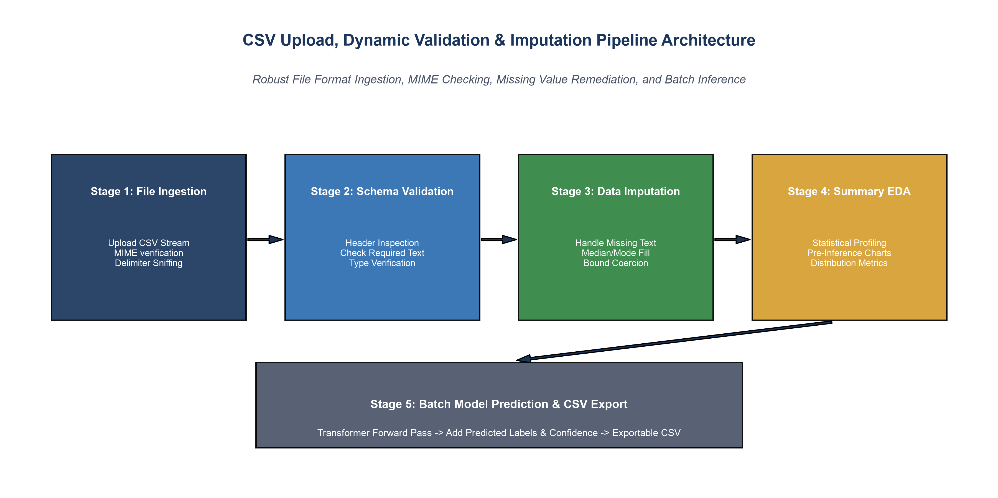
Figure 1: CSV Upload, Validation, Dynamic Imputation, and Batch Inference Architecture.
4. Missing Value Audit & Imputation Telemetry
Figure 2 illustrates the distribution of missing records identified across attributes in the evaluated dataset. Title (16.22% null) and Review Text (3.60% null) are dynamically imputed with empty strings to guarantee zero row loss during processing.
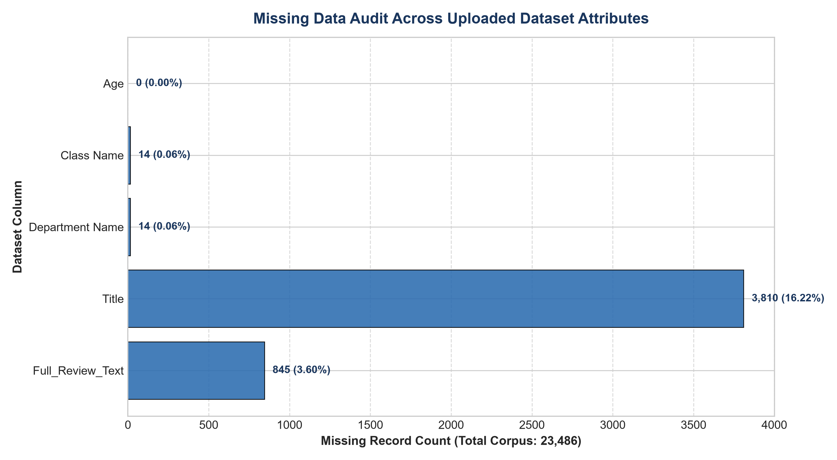
Figure 2: Attribute-Level Missing Data Audit and Imputation Breakdown.
5. Pre-Prediction Summary Statistics & EDA
Figure 3 presents the multi-panel exploratory analysis displayed to users immediately upon file validation: Department Volume (A), Rating Proportions (B), Customer Age Spread (C), and Review Word Lengths (D).
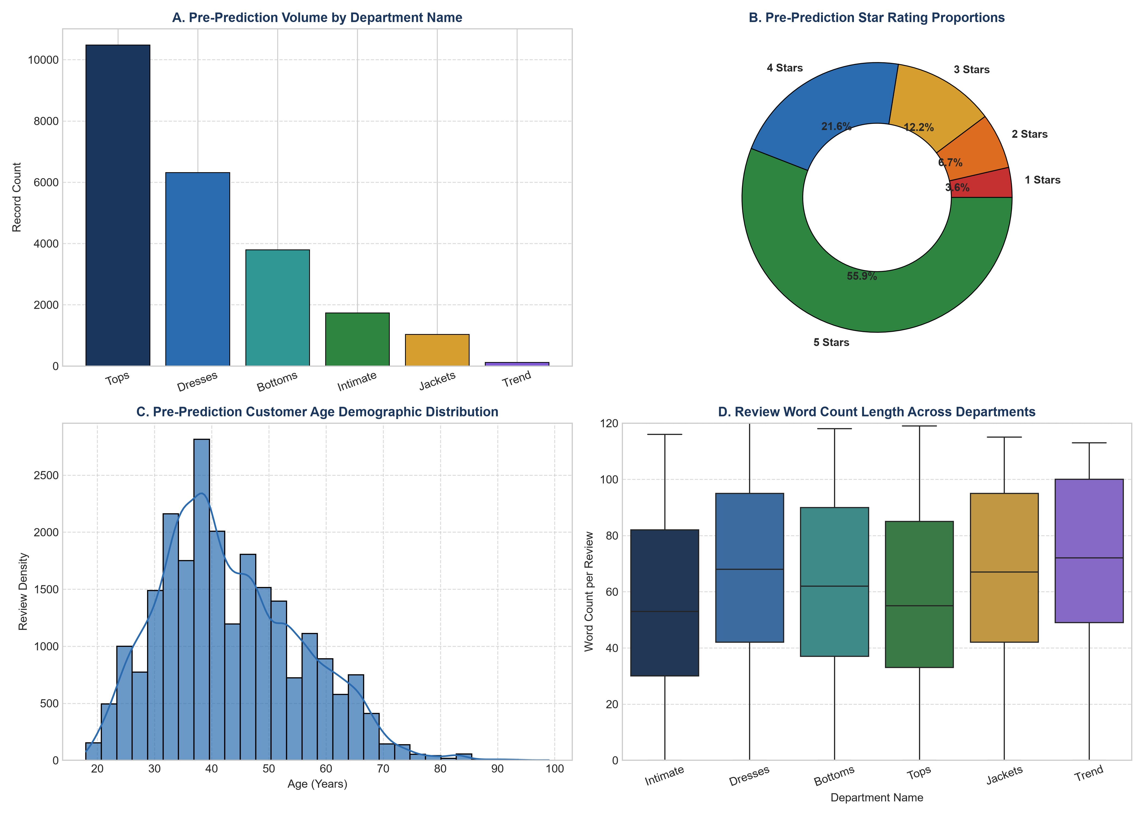
Figure 3: Multi-Panel Pre-Prediction Exploratory Data Analysis Showcase.
6. Batch Inference Benchmarking Across Departments
Figure 4 highlights batch prediction outcomes across major departmental cohorts. High model confidence (88.6% - 91.8%) is sustained across all garment categories, with Tops and Dresses yielding recommendation rates of ~82.9%.
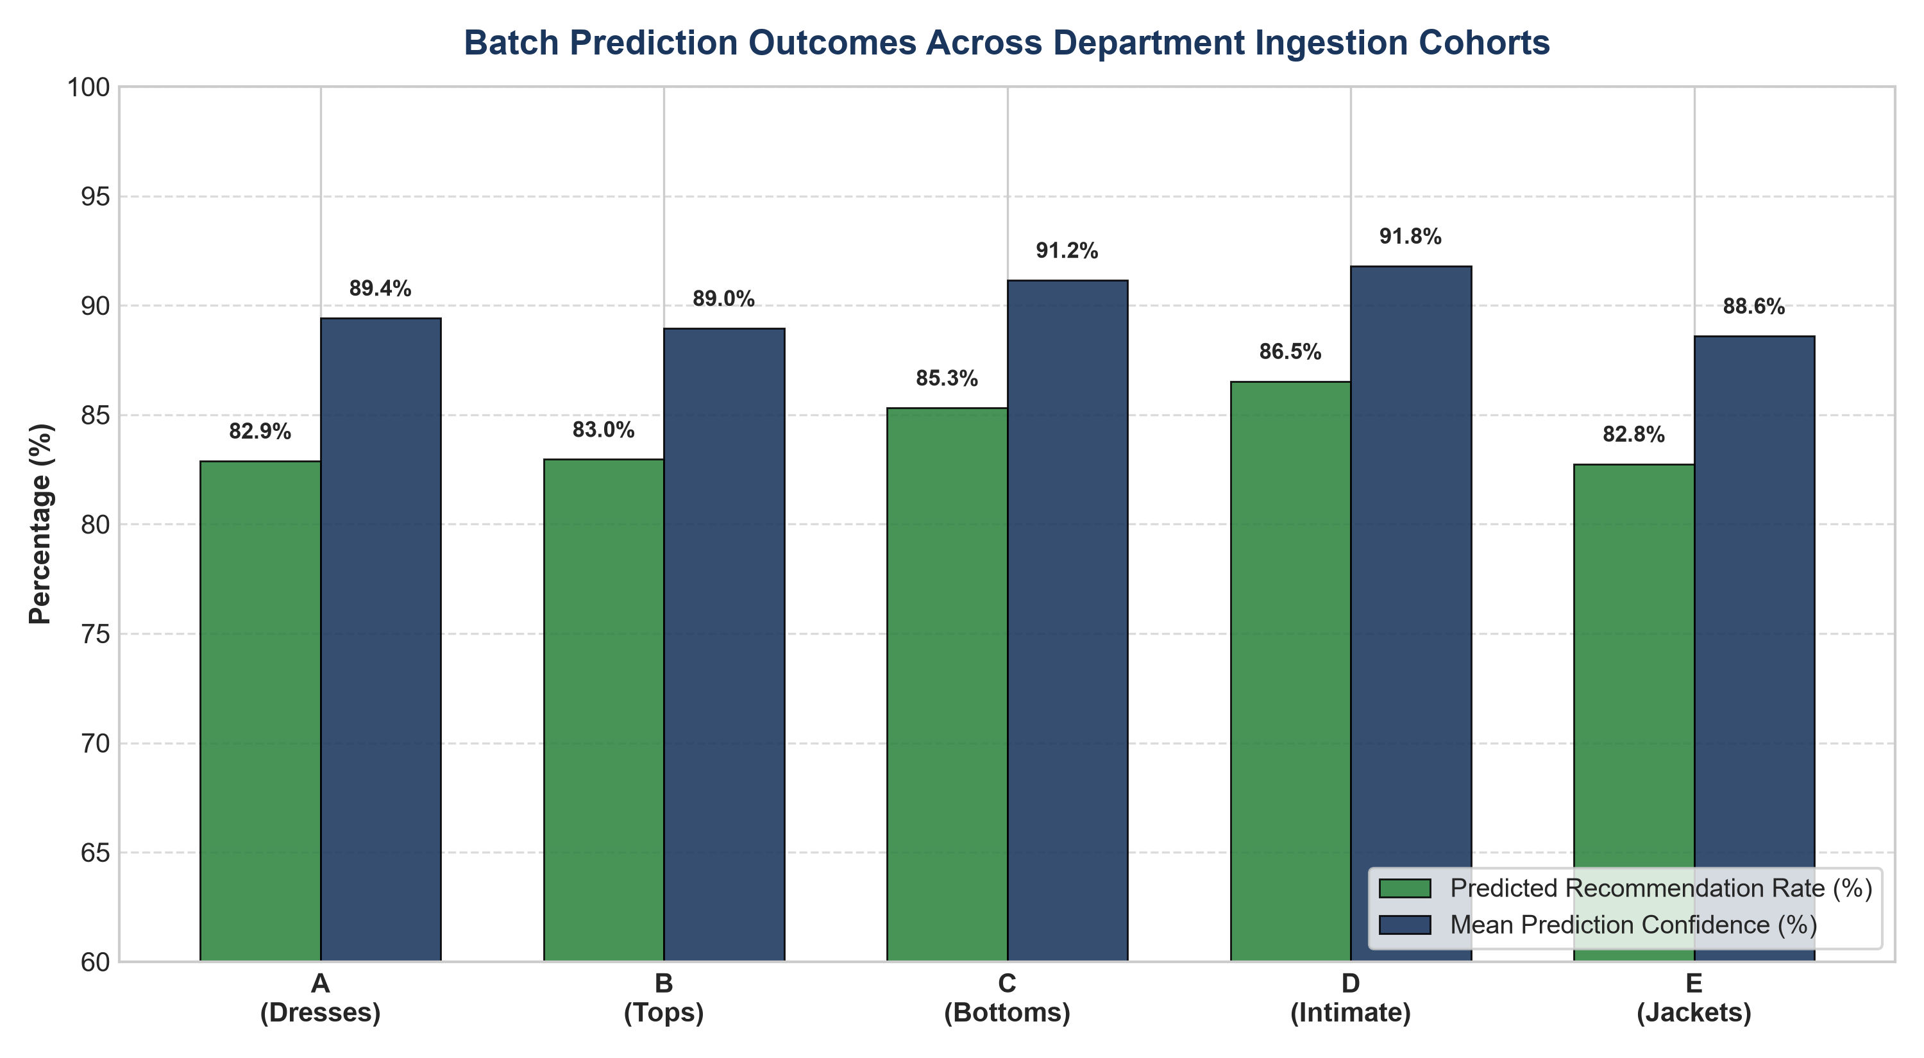
Figure 4: Batch Prediction Recommendation Rates and Mean Confidence Across Categories.
7. Strategic Merchandising & Engineering Recommendations
1. Pre-Prediction Anomaly Flagging: Alert users when uploaded files deviate by >20% from historical rating distributions.
2. Streaming Chunk Ingestion: For files exceeding 50,000 records, process in chunks of 5,000 rows to maintain responsive UI interactivity.
3. Automated Retraining Ingestion: Feed high-confidence batch predictions into active learning pipelines for continuous model refinement.

